**Country Assignment Script v2**

**Task – TQUT**

Description

The intention for this script is to take in existing requirements and append the Country Name, GENC3, and AOR for the geographic area for which they reside in.

Version 2 of the script will introduce a new option. Dominant country (a) will append information based on which country overlaps the footprint the most. Option water body (b) will append information based on which water body intersects the footprint the most. Option boarder (c) will append information based on the route a, but if a boarder is detected the output will contain an abbreviate text of the two countries and a border designator.

This will be a multiprocessing script because it will be ran multiple times as new footprints come in, the process will take a long time because it is spatial, and it is a critical item for developing our weighting algorithms.

Visual

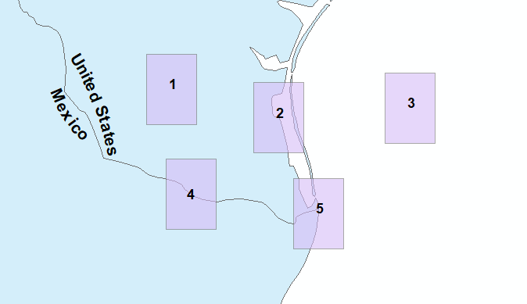

Example

1a – Footprint is fully in one county – Receives the countries name, GENC3, and AOR

2a – Footprint covers both a single country and water – Receives the countries name, GENC3, and AOR

3a – Footprint completely covers water – Receives N/A for country, GENC3, but AOR from AOR file.

3b – Footprint completely covers water – Footprint receives the water body name, and AOR.

4a – Footprint covers 2 countries – Receives the country, GENC3, and AOR of the country it is most in.

4c – Footprint covers 2 countries – The footprint receives an abbreviated value of the two intersecting countries.

5a – Footprint covers multiple countries/water features – Receives the country, GENC3, and AOR of the country it is most in.

Pseudocode

1 – Tabulate Intersect of the footprint and the country polygon or water body polygon.

2 – Make a dictionary from the resulting information looking something like.

{Feature5: {Count: 3,

Intersects: [USA, 20, MEX, 30, WATER, 50] } }

3 – Decision Tree based off the count number

Count == 1 -> Assignment

Count == 2 -> if water in list -> Assignment

-> else -> Decision -> Assignment

Count >= 3 -> Decision -> Assignment

Decision Function will read the counts, with their sources and decide what the dominate item is or the two dominant values in alphabetical order.

Assignment will create a list of item’s ids with their update values.